Monday

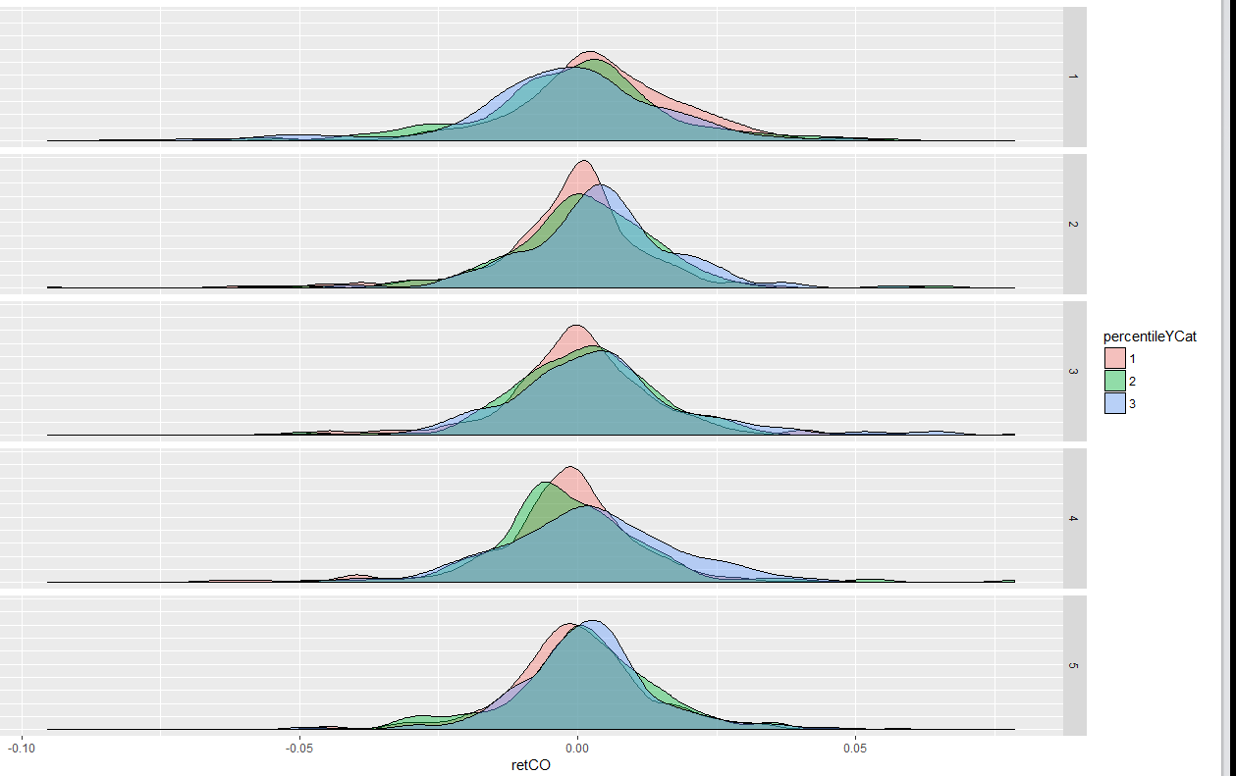

The above graph is retCO by weekday, filling by percentileY (1 is highest, 3 is lowest).

One can see that a strong Friday helps Monday. A strong Monday hurts Tuesday.

A weak Wednesday hurts Thursday.

> aggregate(apr17Data['retCO'], list(percentileYCat, weekday), function(m) sprintf("%.4f",c(mean(m),median(m))))

Group.1 Group.2 retCO.1 retCO.2

**1 1 1 0.0040 0.0035 339 (43%)**

2 2 1 -0.0006 0.0010 211 (26%)

3 3 1 -0.0025 -0.0013 242 (31%)

4 1 2 -0.0018 -0.0002 400 (49%)

**5 2 2 0.0012 0.0014 152 (19%)**

**6 3 2 0.0037 0.0036 262 (32%)**

7 1 3 0.0007 -0.0001 394 (48%)

**8 2 3 0.0011 0.0021 178 (22%)**

**9 3 3 0.0038 0.0029 241 (30%)**

10 1 4 -0.0024 -0.0015 387 (48%)

11 2 4 -0.0008 -0.0033 164 (20%)

**12 3 4 0.0020 0.0016 261 (32%)**

13 1 5 -0.0000 -0.0005 303 (38%)

**14 2 5 0.0010 0.0009 175 (22%)**

**15 3 5 0.0019 0.0018 328 (41%)**

Monday: 43% are eligible for long.

Tuesday: 51% eligible for long.

Wednesday: 52% eligible for long.

Thursday: 32% eligible for long. **68% eligible for short.**

Friday: **63% eligible for long.**

Markets open @ 49bps discount. Any news? Wait for 5 minutes after open to see.

Markets quickly selling off.

No buying today.

The question is should I cut the 1 lot or not. Preliminary answer is no. No buying either. Good thing not much position is on. This is another example of having light positioning unless an opportunity appears. An opportunity appears when the previous close was at a high or at a low, then the next day has a strong tendency to mean-revert.

Now the futures is at flat again, showing the market is not scared.

Empirical experience indicates that positioning must be light and can only increase after a big up or down. I have about 15% of delta on. On the day of the big drop, buy at the day's end at a big discount is good. Shorting at a premium is also good.

Expected return is negative today. End of day percentile is skewed to the left.

Don't buy too quickly, wait for good opportunities like last Wednesday when people start dumping like crazy, that is a good entry point. Keep positioning low at other points.

1009

Markets rebounded. Friday's high helped with today's rebound.

> sum(crashCO3)

[1] 122

> sum(crashCO3[weekday==1])

[1] 34

> sum(crashCO3[weekday==1 & percentileYCat==1])

[1] 6

> sum(crashCO3[weekday==1 & percentileYCat==2])

[1] 11

> sum(crashCO3[weekday==1 & percentileYCat==3])

[1] 17

One sees that with a strong Friday, the chance of a crash is quite low.

More detailed retCO analysis:

|  |
| --- |
| > aggregate(apr17Data['crashCO3'],list(amFirst5>0, percentileYCat,weekday) ,function(m) sum(m))  Group.1 Group.2 Group.3 crashCO3  Monday total: 34  1 FALSE 1 1 5  2 TRUE 1 1 1  3 FALSE 2 1 7  4 TRUE 2 1 4  **5 FALSE 3 1 14 (周五弱容易大跌)**  6 TRUE 3 1 3  Tue total: 26  **7 FALSE 1 2 14 (周一强, 周二低走容易大跌)**  8 TRUE 1 2 3  9 FALSE 2 2 4  10 TRUE 2 2 0  11 FALSE 3 2 2  12 TRUE 3 2 3  Wed: 20  **13 FALSE 1 3 10 (周二强,低走容易大跌)**  14 TRUE 1 3 3  15 FALSE 2 3 2  16 TRUE 2 3 2  17 FALSE 3 3 3  18 TRUE 3 3 0  Thu: 27  **19 FALSE 1 4 15 (周三强, 低走容易大跌)**  20 TRUE 1 4 2  21 FALSE 2 4 4  22 TRUE 2 4 0  23 FALSE 3 4 5  24 TRUE 3 4 1  Fri: 15  25 FALSE 1 5 6 (周四强, 周五低走)  26 TRUE 1 5 0  27 FALSE 2 5 2  28 TRUE 2 5 2  29 FALSE 3 5 1  30 TRUE 3 5 4 |
|  |
| |  | | --- | |  | |

Crash purely on first 5 return:

> aggregate(apr17Data['crashCO3'],list(amFirst5>0,weekday) ,function(m) sum(m))

Group.1 Group.2 crashCO3

1 FALSE 1 26 (76%)

2 TRUE 1 8

3 FALSE 2 20 (77%)

4 TRUE 2 6

5 FALSE 3 15 (75%)

6 TRUE 3 5

7 FALSE 4 24 (89%)

8 TRUE 4 3

9 FALSE 5 9 (60%)

10 TRUE 5 6

More detailed:

> aggregate(apr17Data[c('retCO','percentile')], list(amFirst5>0, percentileYCat, weekday), function(m) sprintf("%.4f",c(median(m),length(m))))

Group.1 Group.2 Group.3 retCO.1 retCO.2 percentile.1 percentile.2

1 FALSE 1 1 0.0013 163.0000 0.6346 163.0000

2 TRUE 1 1 0.0068 176.0000 0.8544 176.0000

3 FALSE 2 1 -0.0033 110.0000 0.5344 110.0000

4 TRUE 2 1 0.0040 101.0000 0.7133 101.0000

5 FALSE 3 1 -0.0055 135.0000 0.3153 135.0000

6 TRUE 3 1 0.0041 107.0000 0.7785 107.0000

7 FALSE 1 2 -0.0022 228.0000 0.5243 228.0000

8 TRUE 1 2 0.0021 172.0000 0.6534 172.0000

9 FALSE 2 2 -0.0013 80.0000 0.5766 80.0000

10 TRUE 2 2 0.0036 72.0000 0.6933 72.0000

11 FALSE 3 2 -0.0011 100.0000 0.6569 100.0000

12 TRUE 3 2 0.0058 162.0000 0.8108 162.0000

13 FALSE 1 3 -0.0009 225.0000 0.5716 225.0000

14 TRUE 1 3 0.0019 169.0000 0.6037 169.0000

15 FALSE 2 3 -0.0025 74.0000 0.5512 74.0000

16 TRUE 2 3 0.0029 104.0000 0.7237 104.0000

17 FALSE 3 3 -0.0016 103.0000 0.6690 103.0000

18 TRUE 3 3 0.0052 138.0000 0.7547 138.0000

19 FALSE 1 4 -0.0028 229.0000 0.4093 229.0000

20 TRUE 1 4 -0.0001 158.0000 0.4482 158.0000

21 FALSE 2 4 -0.0051 89.0000 0.2906 89.0000

22 TRUE 2 4 0.0012 75.0000 0.5882 75.0000

23 FALSE 3 4 -0.0004 121.0000 0.4989 121.0000

24 TRUE 3 4 0.0043 140.0000 0.7157 140.0000

25 FALSE 1 5 -0.0018 157.0000 0.5102 157.0000

26 TRUE 1 5 0.0025 146.0000 0.5695 146.0000

27 FALSE 2 5 0.0002 75.0000 0.5396 75.0000

28 TRUE 2 5 0.0018 100.0000 0.6267 100.0000

29 FALSE 3 5 -0.0003 113.0000 0.5143 113.0000

30 TRUE 3 5 0.0029 215.0000 0.6650 215.0000

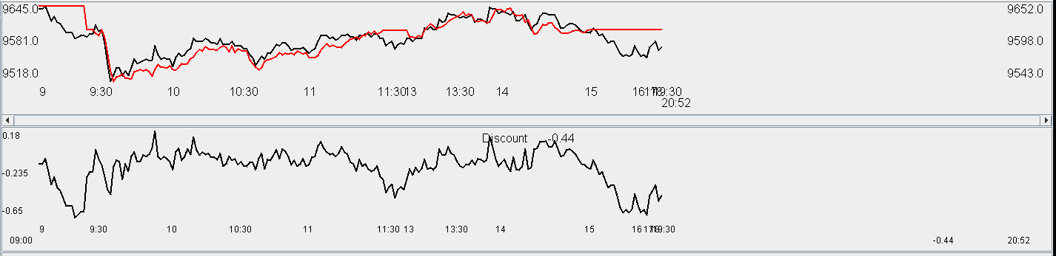

Tuesday, April 26, 2016

Short 1 lot in the morning

Markets rushed up indicating a bullish session – will stop shorting. Markets are trading at a 0.13 premium.

Learn to trade in difficult situations. Manage position size discretely.

Markets are bullish, so do not add short position at this point.

So why short? Just for mean reversion. Hold a bit.

Covered the position at flat. Shorted a bit early today. There was about 80 bps of potential shorting profits to be made.

Shorting when T-1 was a strong day is the most comfortable situation. Yesterday had a big CL and was not a particular strong day.

**Wed**

Tomorrow futures will expire. The long rolling will push the futures into a premium by the experience in march. Entered at a discount of 20 bps.

Market goes to 0.2 premium. Index opens up only 10 bps.

Selling off a bit. Market participants are scared of last week's Wednesday. Trading flat. Market goes to 15 bps discount.

1010 update: markets at 20 bps discount, the market is quite confused now. It panicked around 9:30 and 10:9. Now it is there not knowing what to do. This shows that last Wednesday was so traumatizing that its effect is lasting until now.

Last week position ballooned quickly without much action. When it was really an opportunity to buy, there was no more bullets. This was the unfortunate part. Do not add position unless the market moves. Markets are in a 50 bps range. Nothing to do.

Hscei rushing up and A50 not moving. shcomp also broke day high. The situation looks interesting. Not easy for the short side at this point.

Weak session with no highlights. The first five minutes set the key for today's weakness, there was never a meaningful rally. The buy point was before the morning greed which was OK.

US apple and twitter tanked. Negative sentiment. US tech companies don't have much going on anyways. I don't see how that's an issue affecting China markets.

**Thurs**

Another session with low volume. Markets broke opening high in the AM and several intra-day trades were done which were good quality. Markets slid back into the close due to Thursday's retCH effect. OK day.

Progress was made on certain esoteric features of R. General skill development in the computer science area needs to be strengthened.

After R has been thoroughly familiarized with, it will be important to move onto Python and Spark with machine learning algorithms. Image processing, etc.

The focus will be increasing computer literacy to the hacker's level. Linux skills will be required to be massively improved. Server building, big data processing, machine learning will be the key areas of focus.

The point is applying cutting edge computer science technology to finance and other related fields.

The important languages to learn are Python and R in the near future.

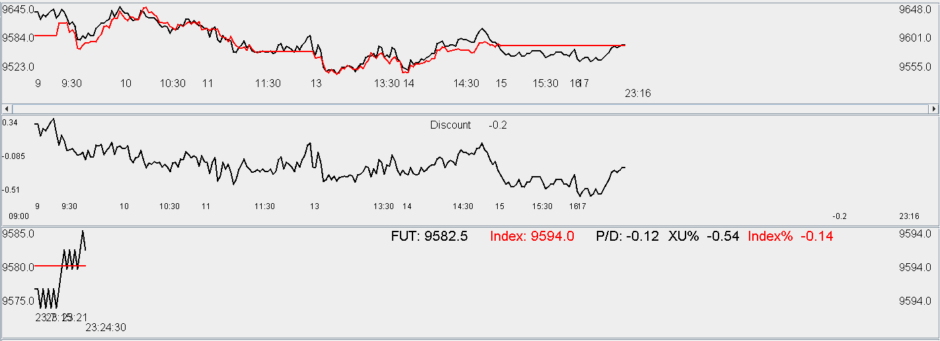

Friday, April 29, 2016

xtabs(~pmMaxEarly+weekday+amClosePercentileCat)

, , amClosePercentileCat = (-1.5,0.33]

**(when am goes down, pm presents an opportunity on Tue, Wed, Fri)**

weekday

pmMaxEarly 1 2 3 4 5

1 153 **132 130** 157 **132**

0 131 **185 182** 141 **167**

, , amClosePercentileCat = (0.33,0.66]

weekday

pmMaxEarly 1 2 3 4 5

1 84 **92** 99 129 110

0 100 **138** 96 110 120

, , amClosePercentileCat = (0.66,1.5]

(For this scenario, it is basically all gambling)

weekday

pmMaxEarly 1 2 3 4 5

1 **118** 134 147 148 140

0 **205** 133 159 127 137

Now let's look at day max:

> xtabs(~dayMaxEarly+weekday+percentileYCat)

, , percentileYCat = 1

weekday

dayMaxEarly 1 2 3 4 5

1 **130** 214 208 **225** 152

0 **209** 186 186 **162** 151

, , percentileYCat = 2

weekday

dayMaxEarly 1 2 3 4 5

1 106 73 87 **96** 88

0 105 79 91 **68** 87

, , percentileYCat = 3

(If Friday closes low, Monday might be a shorting opportunity. Tuesday is a good tradable opportunity if Monday was weak)

weekday

dayMaxEarly 1 2 3 4 5

1 **145** **114** 122 121 166

0 **97** **148** 119 140 162

Let's look at amMaxEarly:

> xtabs(~amMaxEarly+weekday+percentileYCat)

, , percentileYCat = 1

weekday

amMaxEarly 1 2 3 4 5

1 120 202 187 168 130

0 219 198 207 219 173

, , percentileYCat = 2

weekday

amMaxEarly 1 2 3 4 5

1 99 **101** **101** 85 96

0 112 **51** **77** 79 79

, , percentileYCat = 3

weekday

amMaxEarly 1 2 3 4 5

1 141 **187 156** **160** **209**

0 101 **75 85** **101** **119**

Today's afternoon is gambling. Trying to sell at 9597.5, which is an aggressive level to sell.

Selling level was a bit aggressive, did not get filled. Going forward, the level needs to be little more down to earth.

Weekly recap:

Monday: good sell, but did not buy the dip due to opening low and heading lower. Later research was done that most of the Monday crashes happen when Friday close percentile is high, so it was relatively OK to buy at that point. Selling was well done, evidence of some perception that that a low retOPC and amFirst5 worsens the retCH.

Tuesday:

Wednesday: Tuesday's high closing percentile

Thursday: Sold in the morning, market soon crashed lower, picked some position and sold in the afternoon, before market got pulled down by Thursday typical retCH.

Friday: Could not sell the position because the level was too aggressive.

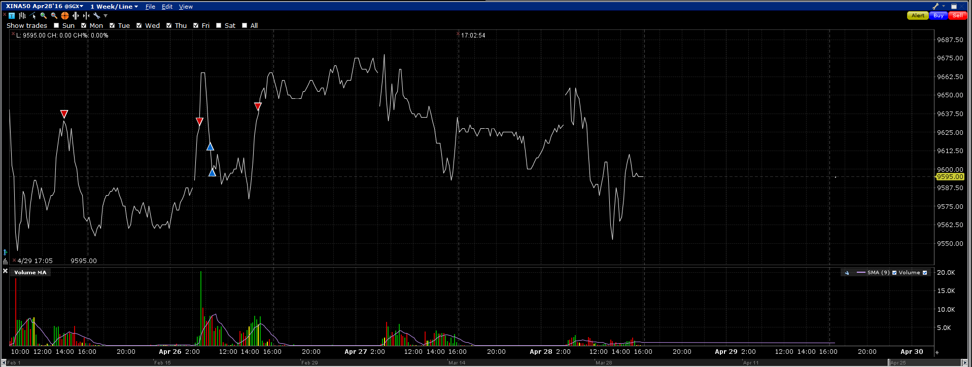

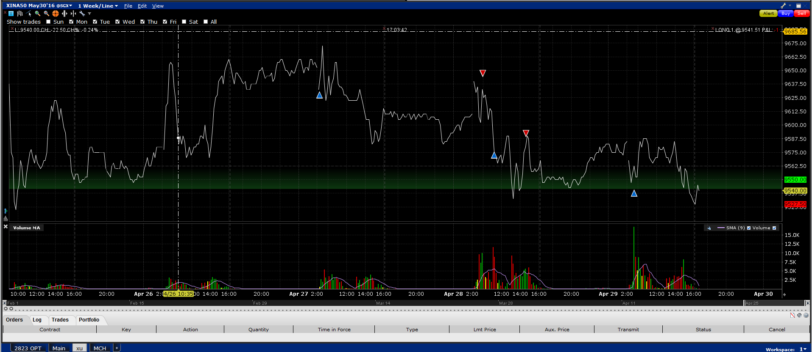

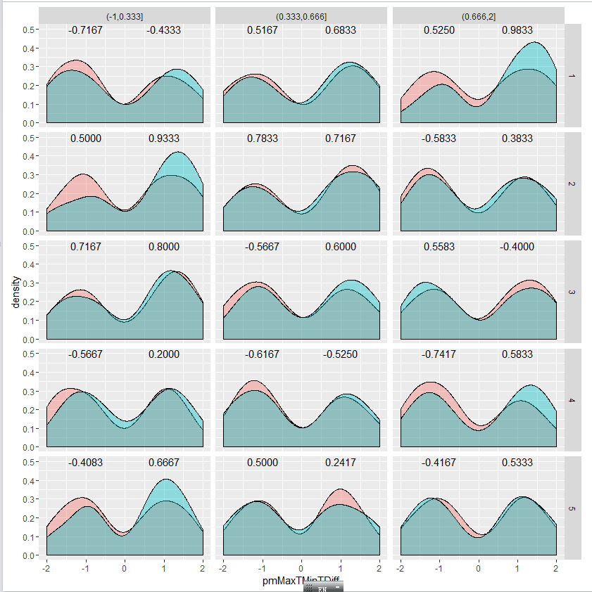

This graph shows that distribution of pmMaxTMinTDiff varying weekday and amClosePercentile. As one can see, on Tue, wed, the rebound is the strongest. On Friday, the rebound is dependent on the first five minute performance.

Thursday is generally shortable except when first five minute is positive.

Friday's strength depends on the first five minutes.

Wednesday, generally needs to long except when AM is strong and amFirst5<0 (this foreshadows pulling down).

Tuesday, long everywhere except when am is strong but amFirst5<0. (AmFirst5 affects are most pronounced in Tuesday, Thursday and Friday. (Check the result on Wednesday)

Monday: long except when am closes at a low, in which weakness is expected to continue into the afternoon.